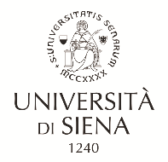

JUST PEACE SCHOLARSHIP 2024 FOR PALESTINE
APPLICATION FORM

PERSONAL DETAILS
Name and Surname:
Date and place of birth:
Nationality:
Present Residence:
Mobile phone:
E-mail:
Passport:

DEGREE COURSE AT THE UNIVERSITY OF SIENA IN WHICH YOU ARE INTERESTED
Course name:

PERSONAL STATEMENT
Summarize in about 5 lines a presentation of your profile

EDUCATION
Year of graduation:
University:
Faculty/Department:
Degree course:
Score:

High school:
Year of obtaining the diploma:
Name of high school:
Type of diploma:
Score:

I authorize the processing of personal data contained in my curriculum vitae according to art. 13 of Legislative Decree 196/2003 and art. 13 GDPR (EU Regulation 2016/679) for the sole purpose of personnel research and selection.

I hereby declare to accept without reserve all the terms and conditions specified for applications for 1 study grant and welcome services for students coming from Palestina enrolling for degree programmes at the University of Siena for the Academic Year 2024-2025.
I also declare to promptly inform the University about any change in the provided data.

Place Date

Signature

