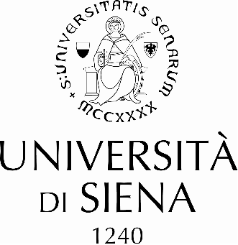

To the Rector
of the University of Siena

To Research and Grants Management Division
of the University of Siena
research.eu@unisi.it

In the framework of the Marie Sklodowska Curie Actions (MSCA) - Post Doctoral Fellowships (PF) Call 2023 and according to current Horizon Europe’s Work Programmes, I ………………………………………..[name, surname]

confirm

- the compliance with the “mobility rule”
- the compliance with the limit of research experience since completion of PhD
- my intention to apply for the “Post-doctoral Fellowships 2023” (call deadline: 13/09/2023) with the proposal entitled [..............................................project title] and with the supervision of ……………………...
- my commitment to jointly draft the project proposal and submit it with University of Siena as Host Institution

…../…../2023
The MSCA-PF-2023 Applicant
(name and surname)

(signature)_____________________

- Identity Card attached
- CV
- Abstract of the proposal with ERC panel/s

for any further information, please visit https://www.unisi.it/ricerca/supporto-alla-ricerca/researchers-towards-unisi-msca-post-doctoral-fellowships-1

Researchers must not have resided or carried out their main activity (work, studies, etc.) in the country of the beneficiary (for European Postdoctoral Fellowships), or the host organisation for the outgoing phase (for Global Postdoctoral Fellowships) for more than 12 months in the 36 months immediately before the call deadline. For researchers wishing to reintegrate from a third country, there must be a direct mobility to an EU Member State or Horizon Europe Associated Country. Compulsory national service, short stays such as holidays and time spent as part of a procedure for obtaining refugee status under the Geneva Convention are not taken into account
At the call deadline, Researchers must have a maximum of 8 years full-time equivalent experience in research, measured from the date that the researcher was in possession of a doctoral degree and certified by appropriate documents. Years of experience outside research and career breaks (e.g. due to parental leave), will not be taken into account.

